# Bass Diffusion

## Assumptions

Two actions/states/behaviour, A and B.

Unidirectional flow of individuals from A to B.

B asymptotically saturates.

2 groups of decision makers, imitators and innovators.

## Model Development

Two actions/states/behaviour, 0 and 1

The model tracks F(t), which represents the fraction of individuals who have adopted action 1 at time t.

Unidirectional flow of individuals from 0 to 1.

P is rate of spontaneous adoption (represents individuals who will switch regardless of other people, i.e free thinkers)

Q is rate of imitation of adoption (represents individuals who will switch if they see other people who have switched, i.e the sheep)

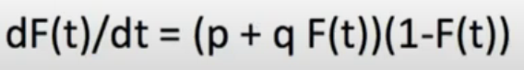

There exists a closed form solution for F(t) (look it up online)

## Advantages

It often provides accurate predictions while relying on few parameters, both of which are easily found through data or past values used in similar applications/industries.

Useful in situations where there is limited contextual information on social structure on industry-specific dynamics that could affect data, working as a very robust base model.

Can be easily modified by adding extra terms to suit the specific context.

## Disadvantages

By itself it makes some large assumptions, which may often not be right for the problem at hand.

Not suitable for multiple actions

## Sensitivity analysis

Standard Schmandard

# **Meyer Notes**